**JAC444 - Lecture 10**

Networking Programming in Java

Segment 1- Basics

Network Programming

**In this lesson you will be learning about:**

* Layering and protocols
* Java Network Programming
* java.net Package

# Elements of a Network

* Communication links:
* point-to-point (e.g., A-to-B)
* broadcast (e.g.,: Ethernet LAN)
* Host: computer running applications which use network (e.g.: H1)
* Router: computer routing packet from input line to output line. (e.g., C)
* Gateway: a router directly connects networks (e.g. A)

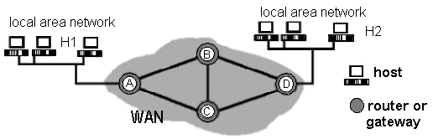

# Networking Basics



**Application**

**(**

**HTTP, ftp, telnet,…**

**)**

**Transport**

**(**

**TCP, UDP, …**

**)**

**Network**

**(**

**IP, …**

**)**

**Link**

**(**

**device driver, …**

**)**

# java.net.InetAddress class

**public static InetAddress getByName(String host)**

**throws UnknownHostException**

**public static InetAddress[] getAllByName(String host)**

**throws UnknownHostException**

**public static InetAddress getLocalHost() throws UnknownHostException**

**public boolean isMulticastAddress() public String getHostName() public byte[] getAddress() public String getHostAddress() public int hashCode() public boolean equals(Object obj) public String toString()**

# Protocol packets

Unit of data exchanged between protocol entities in a given layer.

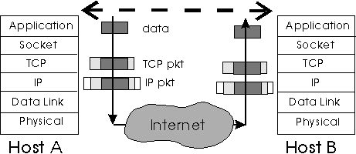

# Uniform Resource Locator

URL is an acronym for *Uniform Resource Locator* and is a reference (an address) to a resource on the Internet.

**http://cs.senecac.on.ca:80/~janastas/index.html#1**

protocol host port file reference

import java.net.*; import java.io.*;

public class ParseURL {

public static void main(String[] args) throws Exception {

URL aURL = new URL("http://cs.senecac.on.ca:80/~janastas/index.html#1");

System.out.println("protocol = " + aURL.getProtocol());

System.out.println("host = " + aURL.getHost());

System.out.println("filename = " + aURL.getFile());

System.out.println("port = " + aURL.getPort()); System.out.println("ref = " + aURL.getRef());

}

}

# Read URL Content

import java.net.*;

import java.io.*; **public class ReadSites { public static void main(String[] args) {**

**for (int i = 0; i < args.length; i++) {**

**try {**

**URL u = new URL(args[i]);**

**InputStream is = u.openStream();**

**InputStreamReader isr = new InputStreamReader(is);**

**BufferedReader br = new BufferedReader(isr); String s;**

**while ((s = br.readLine()) != null) {**

**System.out.println(s);**

**}**

**} catch (MalformedURLException e) {**

**System.err.println(e);**

**} catch (IOException e) {**

**System.err.println(e);**

**}**

**}**

**}**

**}**

# Conclusion

**After completion of this lesson you should know:**

* How to write Java Programs using **java.net.\***
* Networking solution using Java packages.
* Client Server Paradigm.
* Socket, ServerSocket and URL Classes.